Message from Philip Hamilton
Chief Executive Officer of the Community Academies Trust.

Your school is an important part of the family of schools that make up the Community Academies Trust

The Community Academies Trust is a successful school based multi academy trust that was founded in 2012 by The Polesworth School and Birchwood Primary School. Our name originates from our shared and determined commitment to ensure communities are well served by their local school. Our schools are:

- Focussed on achieving outstanding academic, personal and social outcomes for the children
- Committed to the moral imperative of community school improvement and improving all children’s lives
- Mutually supportive, not in competition and fiercely loyal to each other
- Equal partners with all other schools irrespective of their phase, size or successes.
- Multi academy trust minded – our schools celebrate the success of others as well as themselves and share accountabilities
- Financially disciplined and committed to fulfilling their delegated responsibilities to the best of their abilities under a robust governance arrangement

This culture and ethos ensures our schools benefit from shared expertise and support. This means we can maintain our attention to your child’s individual talents and potential. My personal commitment to your child is illustrated by this story:

“As the old man walked the beach at dawn, he noticed a young man ahead of him picking up starfish and flinging them into the sea. As he caught up with the youth, he asked him why he was doing this. The answer was that the stranded starfish would die if left until the morning sun. The old man said that there were millions of starfish, and how could he possibly make a difference. The young man looked at the starfish in his hand, and threw it into the waves to safety “it makes a difference to this one” he said.

The main message from this story is clear – your child will thrive if we all make sure we focus on them as individuals, get to know them well, meet their needs and be ambitious for them.

Our schools are all unique places and at different stages in their journey to providing truly world class schooling for your child. However all are orientated around achieving excellent provision and are constantly reflecting on what is best for your child’s education. All of us in our trust are committed to your child and to them achieving socially, personally and academically and leaving school with a crucial sense of possibility - vital for success in life.

You can find out more about our Trust online at our website – www.communityacademiestrust.org

Very best wishes
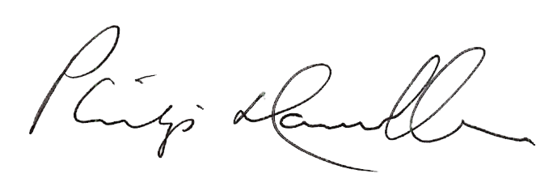
Philip Hamilton
CEO

