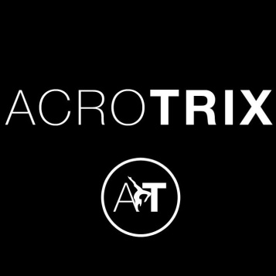
Thursday ACRO-GYMNASTICS 12th September 2019
Years: All years welcome
£58.50
Do you Love Acro-Gymnastics? If yes then you will love our brand new afterschool club. This term in Acro-Gymnastics club; you will be entering the circus and becoming acrobats. Learn new Tricks, Lifts and Balances with your class mates. Learn new routines; work on cartwheels, forward rolls, bridges, forward walk overs and much more in this amazing after school club.

Students Name and Age:…………………………………………………………
Any Medical Conditions:……………………………………………..
Contact Number:………………………………………………………..
Payment made to the school please.
Contact details:
Kerry Childs
07855533442
Kerrychilds1989@outlook.com

EXCITING NEW CLASSES!
We have some brand new classes starting after school on a Thursday evening on Thursday 12th September!
Acrotrix: Gymnastics based classes which include lifts, tumbling and gymnastics. We will work on routines and drills in the classes.
Dance Fusion: A dance class that combines three different genres of dance; Street Jazz, Commercial and Contemporary. We will create different routine for the different genres used.
3:15-4:00pm Acrotrix After school club for All years @ Heathcote Primary School

4:00-4:45pm Dance Fusion: Street Jazz, Commercial and Contemporary
Ages 6-11 years

4:45-5:30pm Acrotrix Intermediate
Ages 6-11 years

5:30-6:15pm Acrotrix Advanced
Ages 12 years plus

6:15-7:00pm Dance Fusion: Street Jazz, Commercial and Contemporary
Ages 12 years plus

7:00-7:30pm STREET DANCE CREW (Invitation only)

