**Computing –**

**Coding:**

Understand what algorithms are; how they are implemented as programs on digital devices; and that programs execute by following precise and unambiguous instructions.

Create and debug simple programs. Online Safety.

**Maths**

**Number – addition and subtraction**

Adding and subtracting 2 digit numbers crossing tens, find number bonds to hundreds.

**Measurement – money**

Counting pennies, pounds and notes. Comparing and finding totals.

**Number – multiplication and division**

Finding and making equal groups

Consolidation of all learning this term.

Built in consolidation weeks to ensure understanding

Mini assessment sessions throughout each block to track understanding.

Maths meetings to recap key themes and consolidate Year 1 learning

**English**

**Reading -** *Key text: Tell me a dragon by Jackie Morris, The Snow Dragon by Vivian French, The Knight and the Dragon by Tomie DePaola, The Egg by MP Robertson A range of appropriate nonfiction texts and online research.*

**Developing pleasure and motivation to read.** Word reading and comprehension skills through class texts and reading sessions and written activities. (Weekly skills building)

Discussing texts and drawing inferences. Choosing own texts and sustained reading for pleasure.

**Speaking and Listening:** discussion and presentation during topic work

**Writing Composition - Writing for different purposes, developing stamina, editing and checking work throughout.**

***Narrative:*** Writing a story, writing a letter, writing a recount, story mapping

***Nonfiction:*** Presenting information in non-chronological reports linked to topic

***Spelling:*** Weekly spellings linked to No-Nonsense spellings

***Grammar:*** Linked to the National Curriculum requirements for Year 2

***Handwriting:*** Children join and enhance the fluency and neatness of their writing.

Emphasis on neat presentation and pride in all written work.

**Religious Education**

**(According to Warwickshire and Coventry agreed syllabus for RE 2017)**

**Engaging pupils in enquiry into significant human questions which religion and worldviews address, so that they can develop the understanding and skills needed to appreciate and appraise varied responses to these questions, as well as develop responses of their own.**

**Key Question:** What can we learn from sacred books?

* Talk about some of the stories used in religion and why people still read them.
* Recognise that sacred texts contain stories which are special to many people and should be treated with respect.
* Re-tell stories and suggest the meaning of these stories. Talk about issues of good and bad, right and wrong.

**Science**

**Broaden scientific understanding of the world through exploration, observation, research and testing in the topic area of** **Everyday Materials**

* Does the weight of a projectile thrown at a castle wall affect the damage done to it?
* Why are bridges shaped in different ways?
* Which biscuit is the strongest and makes the best bridge?

**French**

* Learn how to great each other in French and ask and answer questions such as: ‘How are you?’ ‘What is your name?’ ‘How old are you?’
* Learn numbers 1 to 20

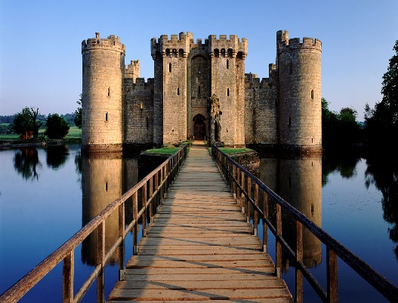

**Music**

**Developing creativity and appreciation and a love of music**

**Charanga: Ho, Ho, Ho**

Colossal Castles

Curriculum Plan –Autumn 2 2020

Year 2

Mrs Abernethy & Mrs Lawson

**Physical Education**

**Developing movement skills, competence, agility and coordination individually and with others across a range of physical activity**

**Games –**  Unit 2 –

Making up games with a partner

To remember, repeat and link combinations of skills in a game, to improve the co-ordination, control and consistency of their actions.

**Dance –** Unit 4 –

to copy and perform simple movements, understand that dance plays an important part in other cultures and throughout history.

**British Values and SMSC**

**Developing an understanding of fundamental British values**

**Spiritual**: Explore the past and how the environment has shaped our community

**Social and moral dilemmas**: consider social and moral dilemmas that they come across in everyday life (e.g. aggressive behaviour, question of fairness, right and wrong, simple political issues, use of money, simple environmental issues)

**Democracy:** Understand how kingdoms were ruled in the past and the rule of the King.

**Rule of Law:** Understand how kingdoms were rules in the past and the rule of the King.

**Individual liberty:**  understand how people in the past would fight to express their views, ideas and freedom.

**Tolerance and respect:** through anti-bullying week, understand that people can have different beliefs, views and ideas and that people can look different, dress different etc and that we should show respect to everyone.

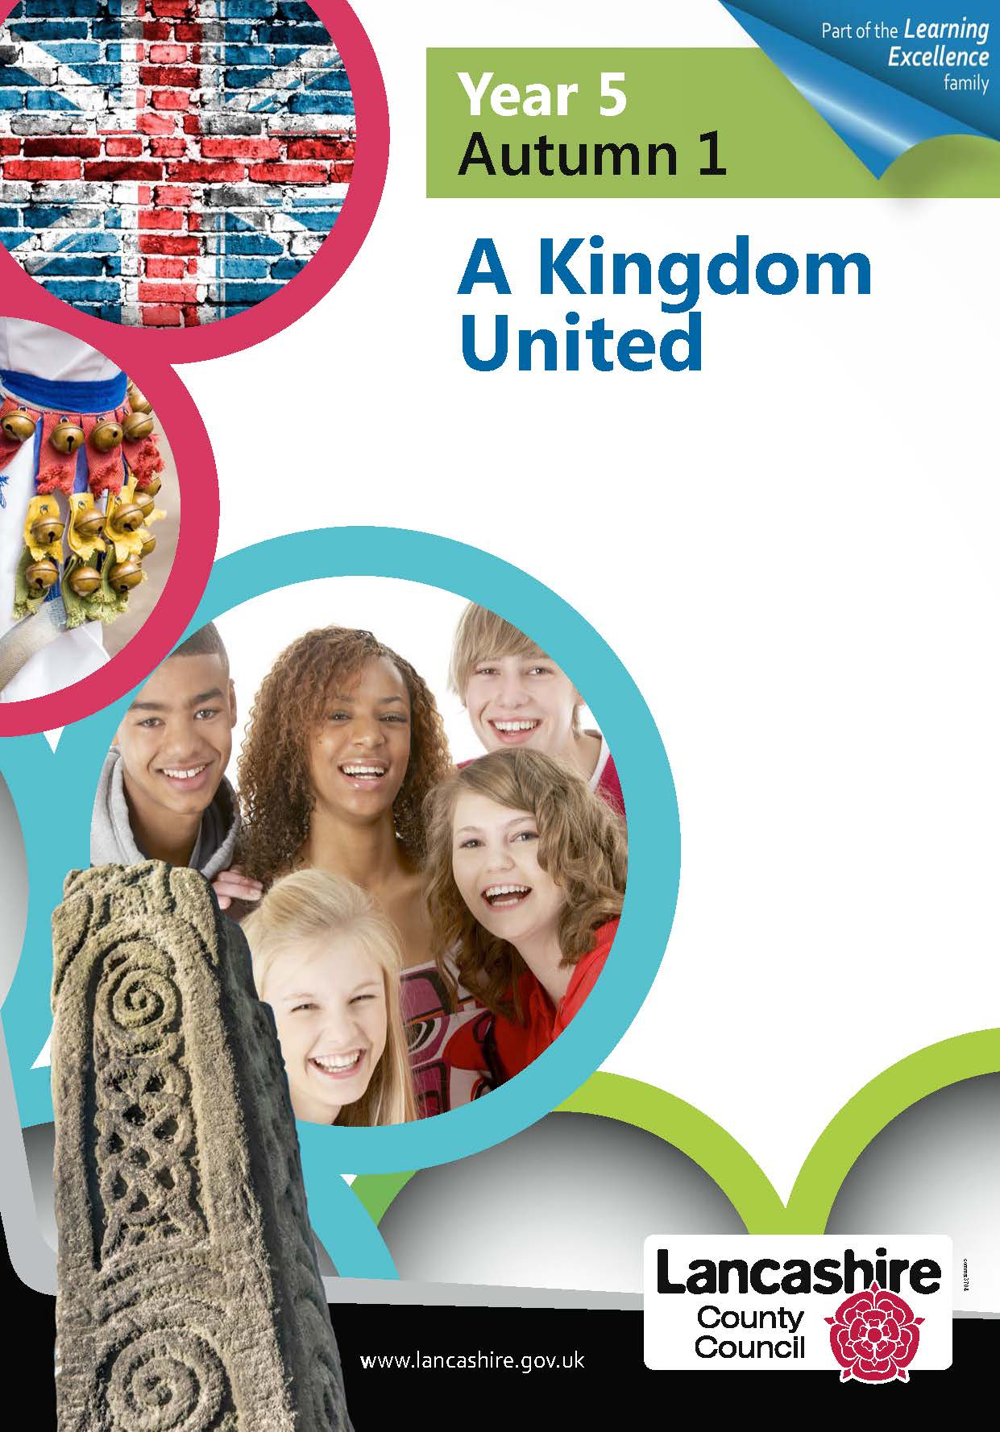

 

**Super Start: Finding a dragon egg**

**Fantastic finish: Christmas festivities**



**Design and Technology**

**Select from and use a wide range of materials and components, including construction materials, textiles and ingredients, according to their characteristics.**

**Select from and use a range of tools and equipment to perform practical tasks.**

-Exploring, designing and making a castle model with a working drawbridge.

**Art**

**Use drawing, painting and sculpture to develop and share their ideas, experiences and imagination.**

* Design and paint a shield
* Watercolour drawings of castles – *‘Castle and Sun’ by Paul Klee*

**Geography**

**Use world maps, atlases and globes to identify the UK and its countries, as well as the countries, continents and oceans studied at this key stage.**

**Use basic geographical vocabulary to refer to key human features, including: city, town, village, factory, farm, house, office, port, harbour and shop.**

* Identify the location of different castles around the UK.
* Explore why castles were built where they were.

**History**

**Learn about events beyond living memory that are significant nationally or globally.**

**Learn about the lives of significant individuals in the past who have contributed to national and international achievements.**

* Research how castles have changed over time.
* Look at what life was like for people in castles.

**PSHE**

**Anti bullying week – United against bullying**

We will also be looking at getting on and falling out, dilemmas and making discussions.

**It also links clearly with our SMSC development.**