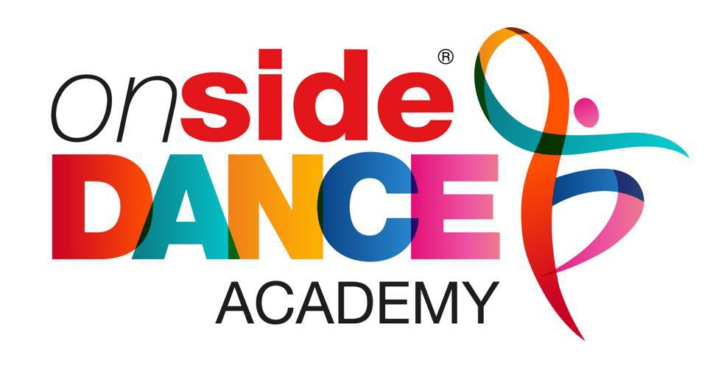

Thursday ACRO-GYMNASTICS
19th September 2019
Years: All years welcome
£54.00

Do you Love Acro-Gymnastics? If yes then you will love our brand new afterschool club. This term in Acro-Gymnastics club; you will be entering the circus and becoming acrobats. Learn new Tricks, Lifts and Balances with your class mates. Learn new routines; work on cartwheels, forward rolls, bridges, forward walk overs and much more in this amazing after school club.

Students Name and Age:…………………………………………………………
Any Medical Conditions:……………………………………………..
Contact Number:………………………………………………………..
Contact details:
Kerry Childs
07855533442
Kerry@onsidecoaching.co.uk

How to book for our AMAZING new classes!

- Visit www.onsidecoaching.co.uk
- Create your log in details
- Click on the book button next to the bear!
- Search for club bookings.
- Click on ‘Onside Dance Academy’
- Book your After School Club!
Example of what to look for!

