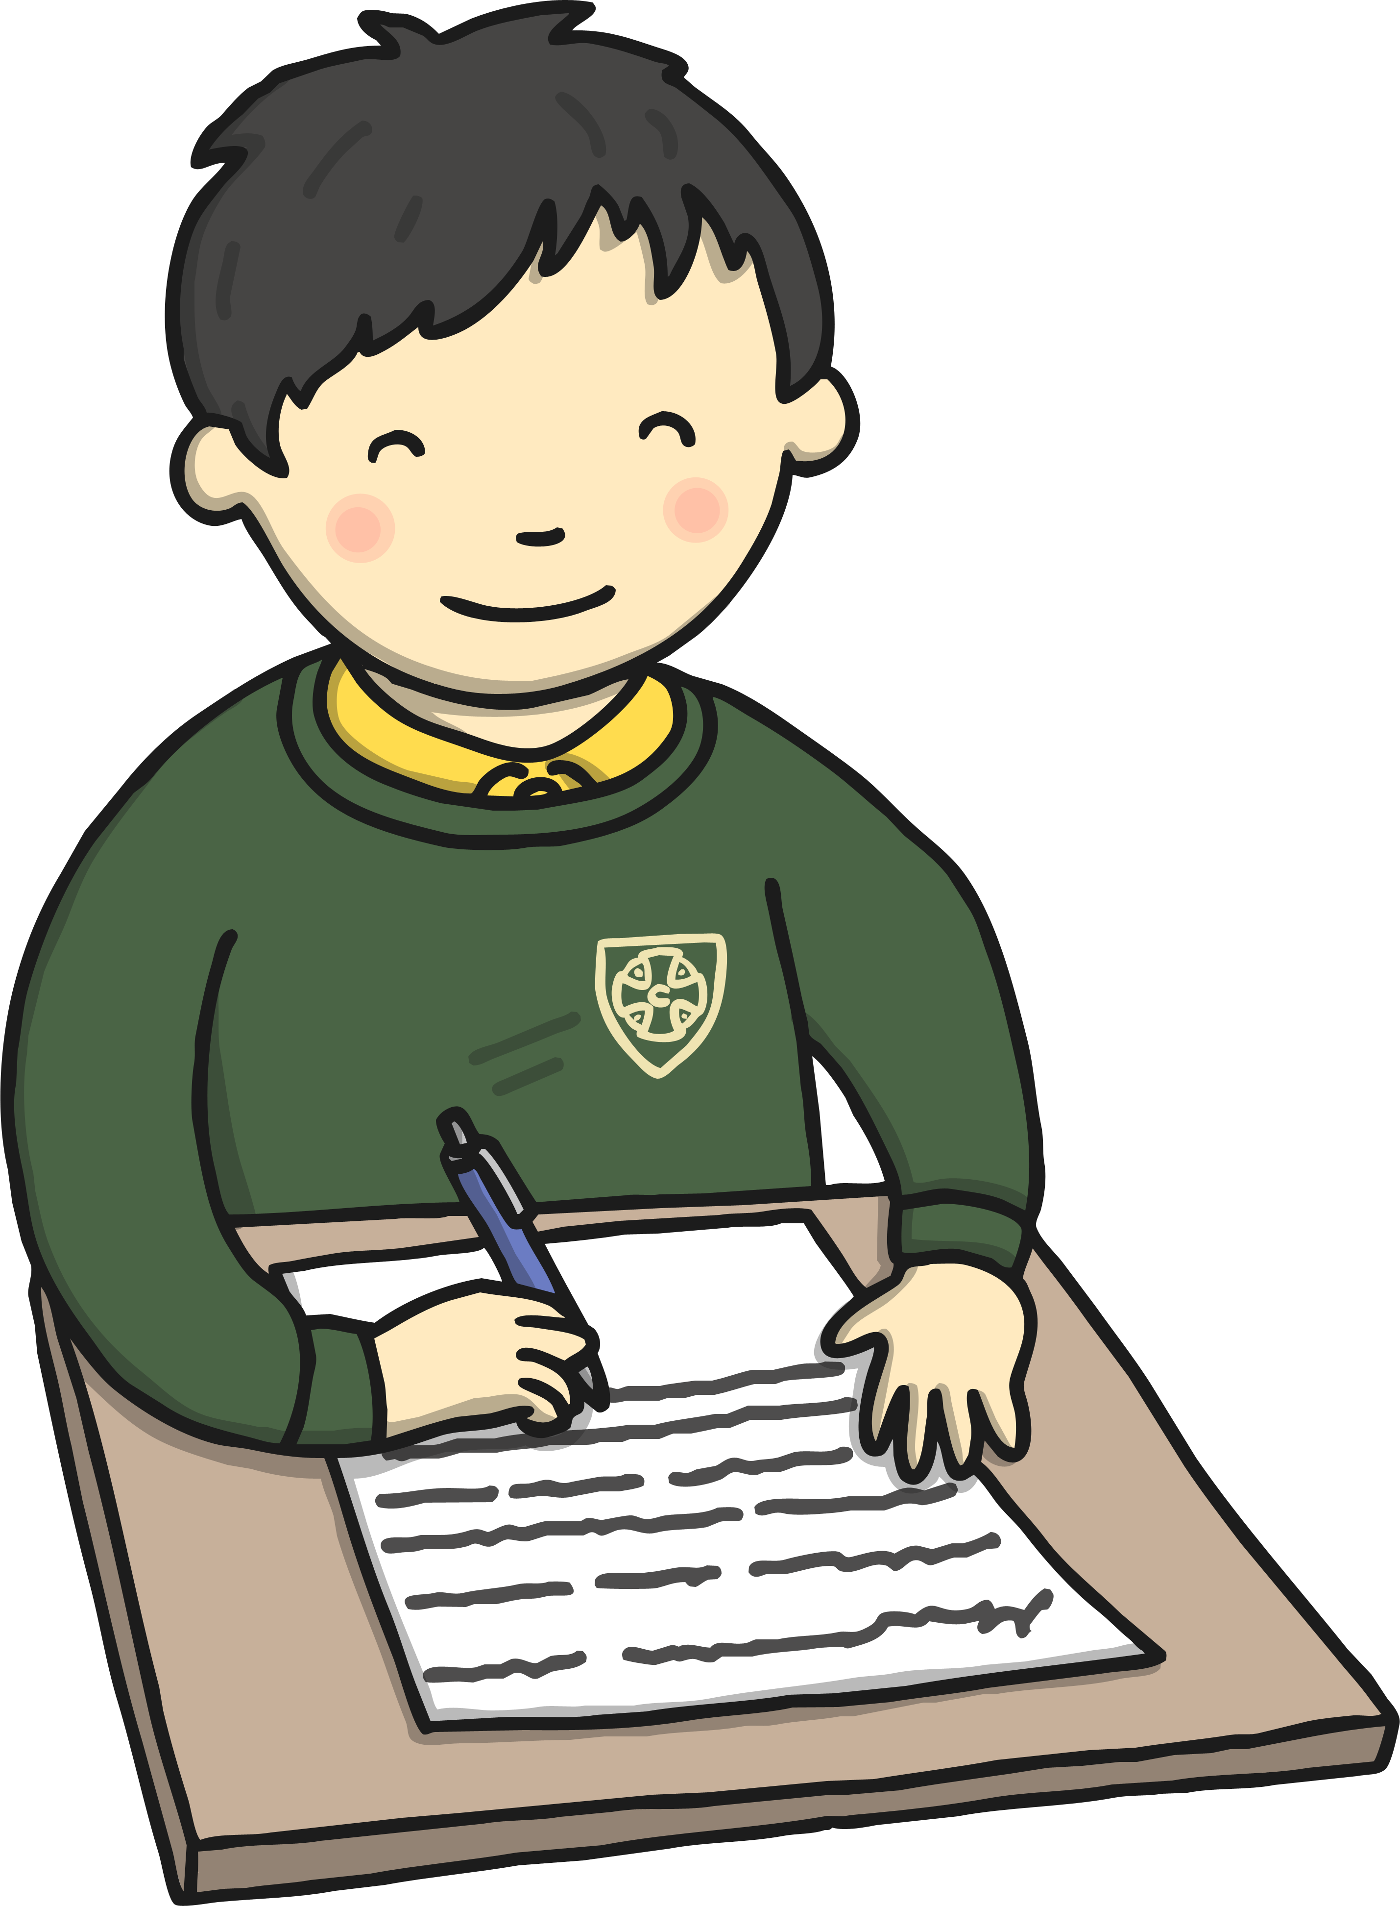
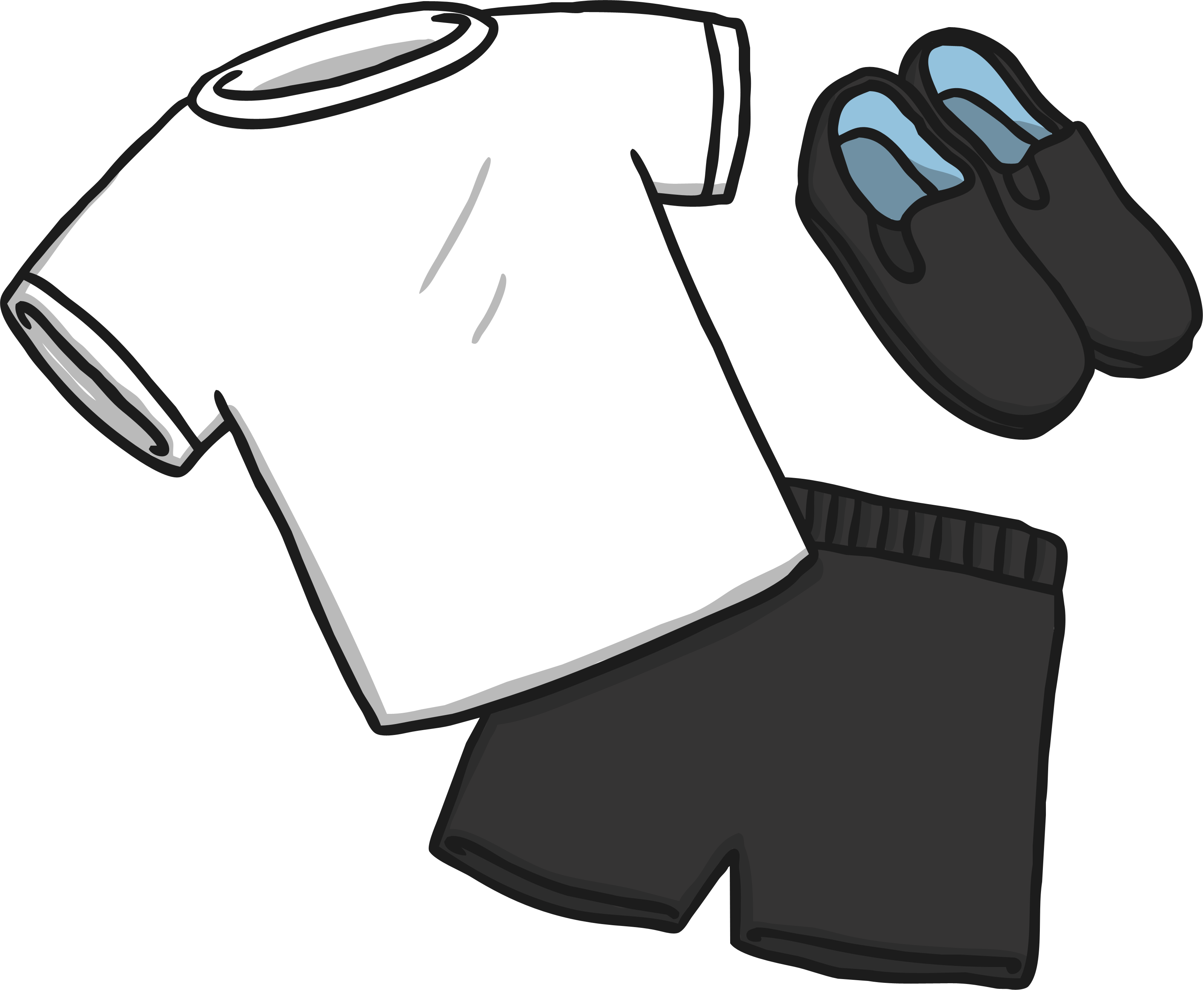

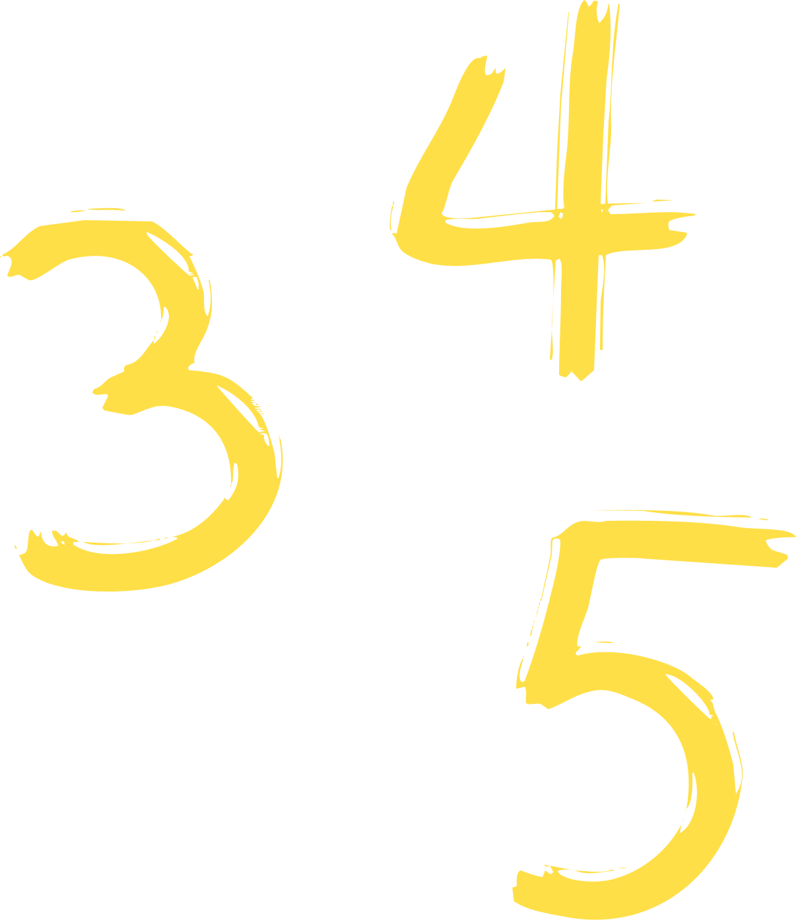
Foxes Newsletter
Autumn 2

Welcome to Autumn 2
Welcome back! We hope you all had a restful half term.
We have lots of exciting learning to look forward to this half term. We started the term with our Pirate Day to mark the beginning of our ‘Land Ahoy!’ topic.
We have some important religious festivals this half term including Christmas and Hanukah, so we look forward to having a half term full of fun and celebrations.
Reminders  Please ensure a named PE kit is in school at all times. Our PE sessions will be Tuesdays and Fridays please ensure that all jewellery is removed on these days. Please can you ensure that your child always has pumps/trainers in school as they will be going outside for PE.  As you know the weather at this time of year can be very changeable therefore please can you ensure your child has a named waterproof coat at school every day, we do go out to play rain or shine.  We regularly keep you up to date through our website class page and Twitter, look at for the #FoxesHEA. | Reading  Last half term we introduced the children to the ‘Awesome Pawsome’ puppies. Each of the puppies focus on a particular reading skill. We will be continuing to work on these skills throughout the year.  We would love to invite you in for a reading afternoon with the children. This will give the children the opportunity to share some of their super questioning skills with you. Friday 29th November at 2pm till around 2.30pm.  We will be asking the children to change their books daily. Some may not finish the text however they will be expected to change on Friday to ensure they have a new book for the weekend.  Please ensure that your child’s reading diaries and book is in school every day.
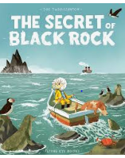
This Half Term
Get your sea legs on, it’s time to sail the salty seas! Navigate, investigate and explore the world- just like Captain Cook.
This half term is all about pirates and explorers. We shall be finding out about the adventures of Captain Cook and the heroic acts of Grace Darling.
Our Core texts this half term are: The Pirates Next door by Jonny Duddle and The Secret of Black Rock by Joe Todd-Stanton. We shall be learning a range of sea shanties and pirate based poetry.
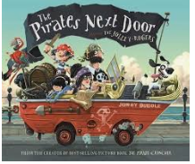
On Wednesday 4th December you will be invited to Year 1 and 2 Christmas Craft and singing afternoon, we hope you will enjoy making some lovely decorations and listening to some beautiful singing.
Please find your curriculum map for this half term attached.

