****School Brochure for Applicants**

***Heathcote Primary School – Heathcote, Warwick***

“Education is for improving lives and for leaving your community and world better than you found it”

*Marian Wright Edelman*

**Achievement in three main areas:**

* Academic – excellent standards and outstanding progress are a prerequisite for success in life equipping young people with the skills and knowledge they will need to be successful, happy and productive citizens.
* Social: Excellent relationships for learning are a prerequisite for all other achievements. Relationships that engender mutual respect between young people, and all other members of our academies’ communities will ensure learning can be fun in a disciplined and caring environment where the highest expectations are the norm.
* Personal: All young people achieve things they can be proud of every day in addition to academic success and outside our school’s planned curriculum. We have a vital role in ensuring individuals develop their own talents and interests and have a responsibility to instil in them a sense of pride in who they are and what they achieve.

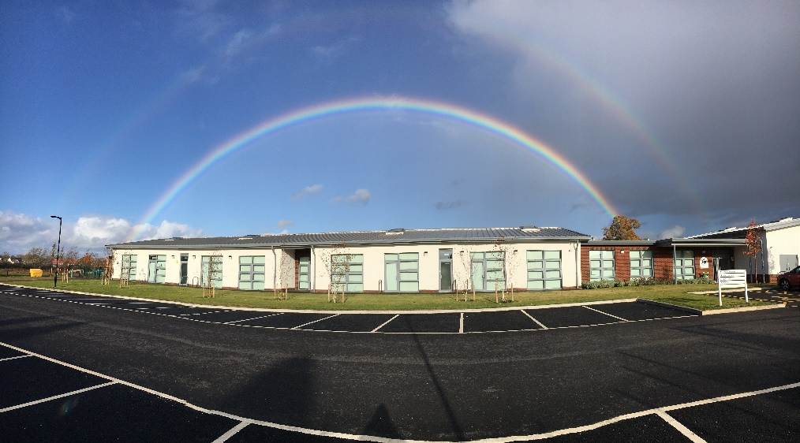

A letter from our CEO – Mr Philip Hamilton OBE

Dear Applicant

Thank you for your interest in joining Heathcote Primary and to make a real difference for young people. **Heathcote Primary** is an important member of our family of community schools.

Our Trust originated as The Polesworth School Academy Trust and then became the Community Academies Trust after going into partnership with Birchwood Primary School in November 2012. Both of these schools are National Teaching Schools. The Trust has grown since 2012 and now comprises five secondary schools and 13 primary schools in Warwickshire, Staffordshire and Telford. Community Academies Trust currently operates in three hubs in Tamworth & Lichfield, Warwick & Stratford-upon Avon and Telford & Wrekin.

Our trust is a values driven organisation, believing fundamentally in the talent of young people and is driven to ensure local communities have exceptional schools. Trustees have set strategic objectives for the trust. These ensure that the schools in our trust are:

• Focused on achieving outstanding academic, personal and social outcomes for the children

• Committed to the moral imperative of community school improvement and shared system leadership

• Mutually supportive and fiercely loyal to each other

• Equal partners with all other schools irrespective of their phase, size or achievements

• Multi academy trust minded – our schools celebrate the success of others as well as themselves and share accountabilities

• Financially disciplined and committed to fulfilling their delegated responsibilities to the best of their abilities under a robust governance arrangement.

This culture and ethos ensure the young people in our care benefit from expertise and support shared across all our schools so that we can maintain our attention to our children’s individual talents and potential. I use this story to illustrate my own personal commitment to the children in our schools:

*“As the old man walked the beach at dawn, he noticed a young man ahead of him picking up starfish and flinging them into the sea. As he caught up with the youth, he asked him why he was doing this. The answer was that the stranded starfish would die if left until the morning sun. The old man said that there were millions of starfish, and how could he possibly make a difference. The young man looked at the starfish in his hand and threw it into the waves to safety “it makes a difference to this one” he said.*

The main message from this story is clear – children will thrive if we all make sure we focus on them as individuals, get to know them well, meet their needs and be ambitious for them.

Our schools are orientated around ensuring excellent provision and are constantly reflecting on what is best for our professionals’ working environment and for the young people in our care. All of us at our Trust want the children to achieve socially, personally and academically and leave school with a crucial sense of possibility - vital for success in life. When you work with us, we are also keen that you will grow as a professional and benefit from our culture of professional development. Your wider professional development is very important to us and we have the capacity through our school networks and the trust wide National Teaching Schools to support you in your work and career.

Yours sincerely



Philip Hamilton OBE Chief Executive Officer

A welcome from our Executive Head Teacher

Dear Applicant,

Thank you for taking an interest in our school and considering joining us in the next step of your career. Heathcote Primary School is in a unique position as we are part of a growing developing community. We are only 5 years old and every year brings new staff and children who are shaping our vision for building a curriculum which instils in children a sense that learning is fun.

We want children to leave our school with an assortment of joyful and rich memories which they value. Throughout their time with us children learn to overcome challenges, build self-esteem and resilience and develop a love for learning so that they can make choices in their future careers. Our curriculum is constantly changing and developing so that we seek ways to stretch children’s abilities. Mountaineers will teach the children how far they can climb, engineers will inspire them to ‘think outside the box,’ archaeologists will instil a love for history, housing developers will teach them how to be eloquent and learn to sell homes. If you think that you can be part of this and creatively inspire children then we would love to hear from you.

Our children are a delight. They are polite, positive and happy. There isn’t a day goes by where you are not greeted by a smile or asked how your day is going. They love to share their learning and want you to join in their activities and care about them.

The team of staff at Heathcote Primary School are extremely positive and welcoming. We work together for the best outcome for children. We are committed to ensuring that as educationalists you are given every opportunity to succeed. We have a comprehensive programme of professional development and there are lots of opportunities to progress in your career. We also work very closely with our hub of schools and those in the trust to provide excellence and progress all pupils. We are also considerate of your well-being. Leaders consider workload, provide time away from the school building and have a social calendar of events.

As a relatively new school our grounds are ripe for development. We already have a wonderful forest school area and great space to enjoy sports. Every classroom has an outdoor area to encourage outdoor learning and soon we will have our very own allotments. We are looking for staff who will continue to nurture a love for the outdoors for our children and develop their mental health and well-being. We also want staff to develop an area of interest so please consider what skills you can bring to our school.

Please visit our website for further information about our school. If you want to talk further about joining us then we look forward to this.

Good luck with your application.

Yours sincerely,

Mrs Gill Humphriss

Executive Head Teacher.

A welcome from our Head of School

Dear Applicant,

My name is Kim Abernethy and I am the Head of School at Heathcote Primary school.  I joined the team at Heathcote in September 2019 but I have worked for Community Academies Trust since January 2017 when I worked at Stratford-on-Avon Primary School.

Heathcote is a fantastic school to work in.  There is a real community feel in the school with staff and children both excited on how we can progress our school further be this through developing our outdoor area, building our allotments, creating links with our community or suggesting fun activities to embed into our curriculum.

Our school has been on an exciting journey over the past couple of years as we’ve continued to grow each year, welcoming more children, families and staff into our Heathcote family.  As you walk around our school, you are always greeted with a smile by children and staff alike and there is a real positive buzz around school.

Working at Heathcote school is an opportunity to join a family that is passionate about working as a team which focuses on building an exciting, creative and engaging curriculum which provides children with the key skills they need in life, a love for outdoor learning and an environment which is inclusive for all.

We look forward to receiving your application and good luck.

Yours sincerely,

Mrs Kim Abernethy

Head of School



**Our children form part of our leadership teams and are always involved in who joins our school. They have shared their thoughts on the type of person they are looking for.**

**Head Boy- Noah**

A new member of staff needs a good sense of humour. They have to be able to help children be ready to learn and take care of children when needed.

**Head Girl - Anjie**

We want you to be positive and help children to resolve their own conflicts'

**School Parliament- Neev and Rajun**

Someone who can treat everyone equally, someone who's friendly and kind. We want someone who makes lessons fun and exciting. They must have a good experience of supporting all kinds of children.

**Some of our children**

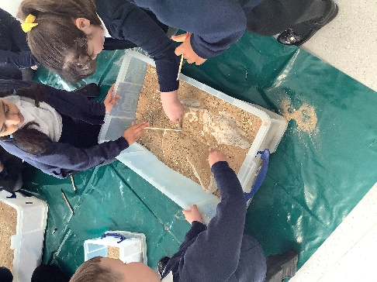"We want someone to be very happy"- Charlie

"I would like a person that likes children"- Freddie

"I would like someone who can do nice things"- Tyler

"I would like a kind person"- Jessica

"I want a person who helps us to help other people"- Nathan

"I would like a person who makes us feel happy"- Anushka

“You should help us to do lots of fun learning"- Amelia

"I would like you to make our work exciting"- Evelyn

"I would like someone that makes us smile"- Daisy

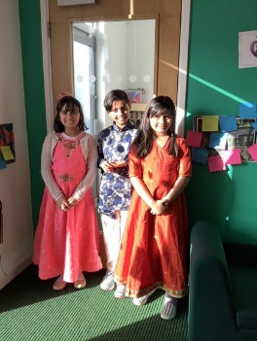

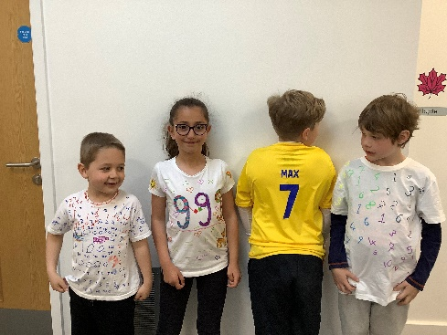

Where are we?

Heathcote Primary School is located in a new housing estate between Warwick and Leamington Spa. There is easy access off the M40.

Heathcote Primary School

Vickers Way

Heathcote

Warwickshire

CV34 7AP





