Maths
Addition and subtraction within 20
Comparison and difference. Represent and use number bonds; read, write, interpret and solve one-step problems
Number and Place Value
count to and across 100, forwards and backwards, beginning with 0 or 1, or from any given number ♣ count, read and write numbers to 100 in numerals; count in multiples of twos, fives and tens ♣ given a number, identify one more and one less ♣ identify and represent numbers using objects 9 ♣ read and write numbers from 1 to 20 in numerals and words
Focusing on:
Counting forwards and backwards to 50
Counting in 2s and 5s.

English – Shh we have a plan and a focus
on Woodland themed traditional Tales
Speaking and listening

Listen to, discuss and express views about books at a level beyond that which they can read independently.
Discuss the significance of the title and events.
Link what they hear or read to own experiences. Explain understanding of what is read.
Discuss the sequence of events in books and how items of information are related.
Discuss favourite words and phrases. Answer and ask questions.
Predict what might happen on the basis of what has been read.
Draw inferences on the basis of what is being said and done.
Reading and Phonics

Daily phonics lessons revising all Phase 3 sounds and Phase 4 blends.
Practise of new Phase 5 sounds.
Group guided reading sessions to support children with their reading skills, with a focus on predicting and making inferences.
Segmenting and blending of sounds already learnt.
Discussion of texts during English sessions where children will ask and answer questions about the class text and its meaning
Learning to read by sight the Year 1 common exception words.
Comparing and contrasting traditional tales including Little Red Riding Hood, Hansel and Gretel and Goldilocks and the Three Bears. Discussing common themes including storyline, setting, characters and plot.

Writing

Children will have the opportunity to write list poems and write their own enchanted woodland stories. They will sequence and plan out events in familiar stories to help them plan their own narrative. They will use a range of traditional tales to compare and contrast characters and use adjectives to complete character profiling and descriptions.
They will create non-chronological reports based on their favourite woodland creatures by researching and collecting information. Children will also write letters and riddles as their favourite characters from our class books.
Computing
To sort items using a range of criteria. To sort items on the computer using the ‘Grouping’ activities in Purple Mash. To understand that data can be represented in picture format. To contribute to a class pictogram. To use a pictogram to record the results of an experiment.

Religious Education
Key Question: What makes some places Sacred?
Children will find out about special places all over the world as well as think about what is a special place to themselves.

We will focus on different faiths: Christianity, Islam and Buddhism, and what special places are to the people who follow these religions.

Music
Into the groove! Charanga.
Remote learning- Children to follow Yumu.

Physical Education
Healthy eating.
Gymnastics.
Remote learning: To follow PE with Joe Wicks

Curriculum Plan – Enchanted Woodland!
Spring 1 2021

Year 1

Mrs Shirley/Miss Newcombe

Science
Science
Seasonal Changes.
Name the four seasons.
Name different types of weather.
Make observations about the weather.
Describe the weather associated with each season.
Collect and record simple data.
Make simple observations about changes across the seasons
Geography
We will be making maps of woodland areas and making a key. We will be beginning to use locational and directional language to describe locations and features on a map.
British Values
Democracy – Looking at what we can do about deforestation.
Rule of law – Investigating why deforestation still happens.
Individual liberty – discussing the importance of trees and how they impact in our lives.
Tolerance and respect – looking at how other people live and how their lives are benefited hugely by deforestation.
Languages
French
Greetings and simple conversations

Super Activities:
A Forest school day experience.

History
We will be focussing on the story of Robin Hood, whilst learning about the history of local woodland areas.

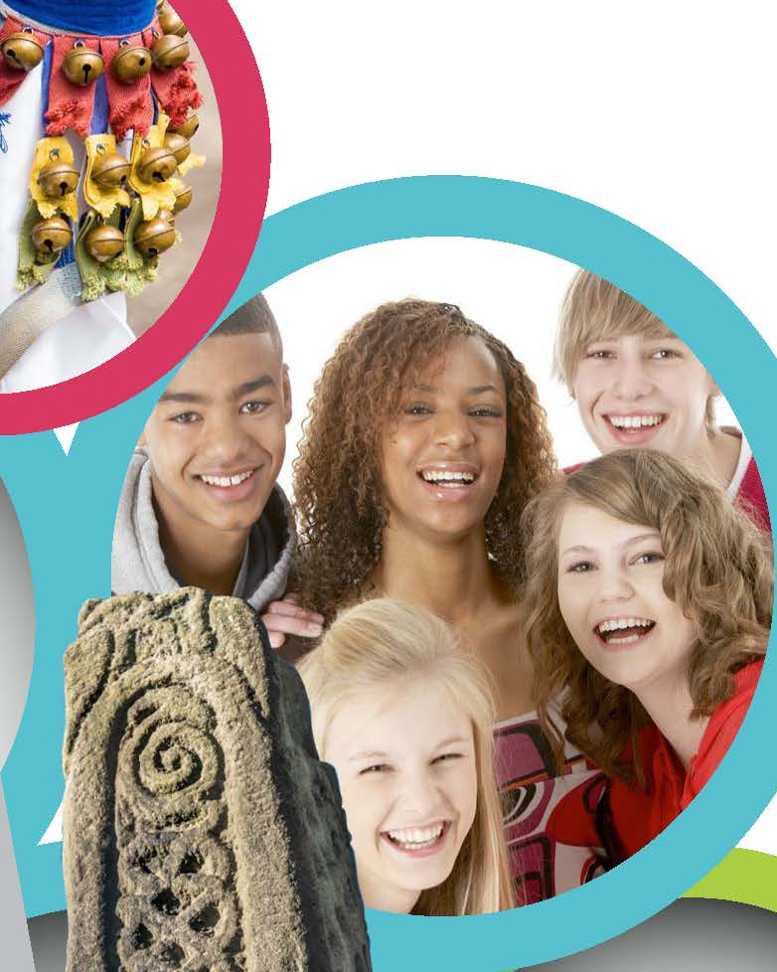
Art and Design and Technology
Art: We will study the art of Andy Goldsworthy and create observational drawings from woodland walks.
DT: We will be creating a woodland crown and make a stickman.

Our key texts

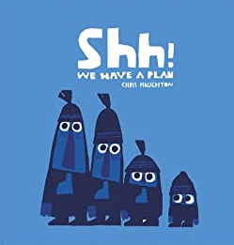
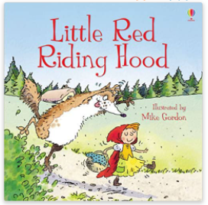
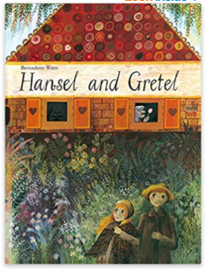

PSHE and Citizenship
Making a positive contribution – To think about themselves, to learn from their experiences, to recognise and celebrate their strengths and set simple but challenging goals. To learn about growing and changing and new opportunities and responsibilities that increasing independence may bring.

