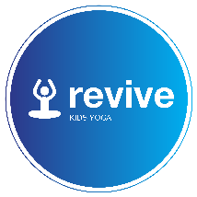

Children’s yoga after school club at Heathcote Primary School

Dear Parent/Guardian
I will be running after school yoga classes during the Autumn term for pupils at Heathcote Primary School. I currently teach classes in the local area and at other schools. Through a mixture of yoga poses and fun games the classes have both physical and mental benefits. These include; improved strength, flexibility and balance, improved concentration, easing anxiety and fostering calmness.

Details:
Day and time: Wednesdays (15.15 -16.15)
Date: 18.9.19 – 23.10.19
Cost: £30 for 6 sessions.
I have 10 spaces available. To secure your child’s place please contact me by email – revivewarwick@outlook.com and I will provide payment details and a short registration form to be filled out.
All mats and equipment will be provided. Children can do the class in their school uniform, although if girls wish to wear shorts etc under school dresses/skirts that is absolutely fine. Please provide a small snack for your child to have before the class starts as I’ve found this really helps with energy and concentration levels!
Please feel free to check out my facebook page *revivekidsyoga which includes photos from my other classes and parent reviews. Similarly if you have any questions please do not hesitate to contact me.
Yours sincerely

Dawn Rahman
Children’s Yoga Teacher
Email – revivewarwick@outlook.com
Tel – 07968 542951

