**Maths**

**Measurement** (length and height)

Compare lengths and heights.

Measure lengths in centimetres and metres and compare and order them.

Use four operations with lengths.

Problem-solving with lengths.

**Geometry** (Position and Direction)

Describe position (left, right, forwards, backwards, above, below), movement and turns (quarter, half, full, clockwise/ anti-clockwise)

**Measurement** (Time)

Recap telling the time- o’clock and half past.

Quarter to and quarter past.

Telling the time to 5 minutes.

**English**

**Reading**

Key texts:

Fiction:

Moth by Isabel Thomas (POR)

The Bad-Tempered Ladybird and other Eric Carle stories

Film/Animation:

Non-fiction: Non-chronological Reports about mini-beasts to make a class guide book.

Poetry: Christina Rosssetti poems- ‘Hurt No Living Thing, Caterpillar and other poetry on the mini-beast theme.

**Developing pleasure and motivation to read.** Word reading and comprehension skills through class texts and reading sessions and written activities. Weekly skills building- Reading Dogs

Choosing own texts and sustained reading for pleasure.

**Speaking and Listening:**.

**Writing Composition - Writing for different purposes, developing stamina, editing and checking work throughout.**

**Nonfiction**: Writing Non-Chronological Reports based on 1) Mini-beasts in general then a chosen mini-beast

**Narrative**: Story writing linked to ‘Moth’ and ‘The Bad-Tempered Ladybird’

Poetry: Write a poem about their chosen mini-beast using alliteration and some rhyming.

***Spelling:*** Weekly spellings linked to No-Nonsense spellings.

***Grammar:***. Expanded noun phrases, co-ordinating and subordinating conjunctions.

***Punctuation:Revision of commas in lists and apostrophes (missing letters and singular possession)***

***Word classes: Revise all word classes.Focus on verbs and adverbs. Use of –ly to turn adjectives into adverbs.***

***Handwriting:*** Enhance the fluency and neatness of their writing. Forming and positioning all upper and lower case letters correctly. Starting to produce a cursive script.

**Science**

**Living things and their habitats**

-Identify that most living things have a habitat which suits their needs**.**

-Describe how animals obtain their food from plants and other animals, using the idea of a simple food chain, and identify and name different sources of food.

**Animals**

-Notice that animals, including humans, have offspring which grow into adults

-Find out about and describe the basic needs of animals, including humans, for survival (water, food and air)

**Investigate habitats in school grounds, go on mini-beast hunts, make and observe a bug hotel over time.**

**Key Questions for investigations:**

**-**Do insects have a favourite colour?

-What is the life cycle of a caterpillar? (Caterpillar observation)

-Do snails have noses?

**Computing –**

**Creating pictures –** using the program 2Paint a Picture, looking at creating and enhancing pictures and images using a range of effects and functions.

**Religious Education**

**(According to Warwickshire and Coventry agreed syllabus for RE 2017)**

How should we care for others and the world and why does it matter?

Key Celebrations:

Ramadan- Monday 12th April till Wednesday 12th May.

Eid al-Fitr- Wednesday 12th May

‘Wriggle and Crawl’

Curriculum Plan –Summer 1

2021 Year 2

Mrs Lawson, Mrs. Abernethy, Mrs Ribbands

and Miss Chadwick

**MFL**

* .

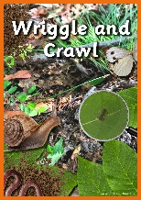

**Design and Technology**

Making a mini-beast puppet with moving parts and/or designing and making a bug hotel.

Finding and making honey-based recipes.

Use them to make class cookery book.

**British Values and SMSC**

**Developing an understanding of fundamental British values**

**Spiritual**: Explore the relationship with their family, especially with elderly relatives.

Understand the importance of spirits in other cultures.

**Social and moral dilemmas**: Look at how festivals and celebrations bring communities together. Consider social and moral dilemmas that they come across in everyday life /

**Democracy:** Understand how kingdoms were ruled in the past.

**Cultural:** explore different countries beliefs and festivals.

**Individual liberty:**  understand how people in different countries would fight to express their views, ideas and freedom.

**Tolerance and respect:** understand that people can have different beliefs, views and ideas and that people can look different, dress different etc. and that we should show respect to everyone.

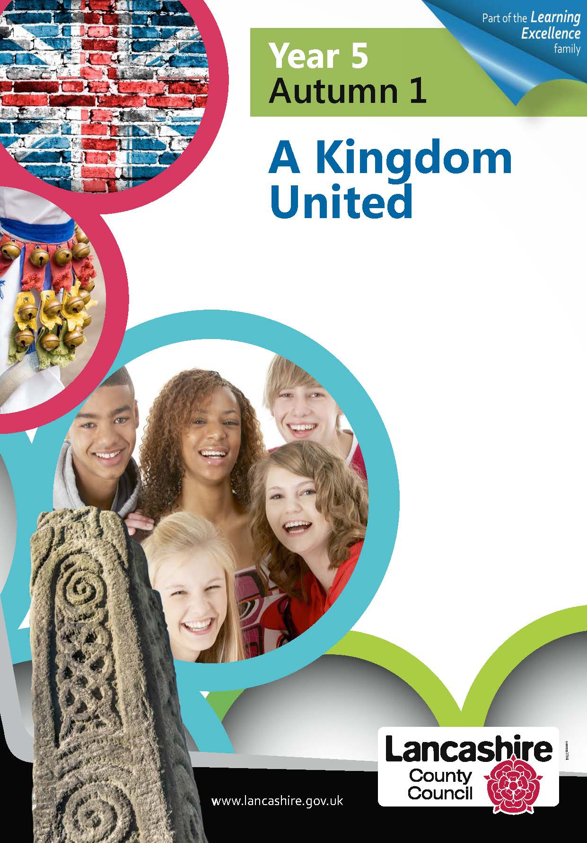

**Physical Education**

**Developing movement skills, competence, agility and coordination individually and with others across a range of physical activity**

**Ball skills-** Develop control and skill of throwing and catching (with a partner, towards a target) Practise striking a ball (from hand and moving) Learn simple versions of small-sided rounders type games in which to practise the above skills and develop strategies, follow simple rules and fair-play/team work.

**Athletics-** Practise running (different distances) and jumping. Improving techniques and measuring and recording times and distances to develop personal bests.

**Art**

**Use drawing, collaging and printing to develop and share their ideas.**

**Drawing- sketches of minibeasts based on the work of Rosalind Monks (intricate patterns)**

**Printing- William Morris (linked to History- Victorians) and habitats**

**Music**

**Developing creativity and appreciation and a love of music**

**Charanga – Friendship Song**

**History (Street Detectives)**

**Local History Study**

Looking at how the local area has changed over time.

What was on the school site/the housing estate in the past? The history of Leamington Spa, focus on the Pump Rooms.

Victorians

Significant person study: Charles Darwin

**Geography (Street Detectives)**

**Locational knowledge:**

Name, locate and identify characteristics of the four countries and capital cities of the United Kingdom and its surrounding seas.

Locate: Warwickshire (county), large cities close to us (Birmingham, Coventry)- what is a city? Towns- Leamington Spa, Warwick, Stratford-upon-Avon (compare size of towns, populations etc)

**Human Geography:**

**Use geographical vocabulary of** key human features, including: city, town, village, factory, farm, house, offices etc.

Reading, using and making maps

**Fieldwork linked to Science- exploring and mapping natural habitats.**

**Geography skills and fieldwork:**

**Use maps and atlases**

**Use fieldwork (around school community) to observe, measure, record and present human features e.g. recycling bins, rubbish collections, monitor waste generated by school/by families etc.**

**PSHE**

**Belonging to a Community- linked to British values and citizenship)**

* Working together in school, in our local community, in Warwickshire to look after the environment (rights and responsibilities)
* Develop team-building skills (through links to ‘The Bad-Tempered Ladybird’ themes, teamwork skills in Summer games, looking at how minibeasts work together ie ants in colonies.

**It also links clearly with our SMSC development.**