**English**

**Reading**

*Key texts:*

*Fiction: (Different stories by the same author- compare/contrast) Stories that raise issues and dilemmas.*

***‘Dinosaurs and all that rubbish’ and ‘One World’ by Michael Foreman***

*Film/Animation: ‘Treasure’ from the Literacy Shed*

*Non-fiction texts and online research linked to pollution, recycling and protecting the environment.*

*Poetry: ‘Jellyfish’ and other Michael Rosen poems.*

**Developing pleasure and motivation to read.** Word reading and comprehension skills through class texts and reading sessions and written activities. Weekly skills building- Reading Dogs

Choosing own texts and sustained reading for pleasure.

**WORLD BOOK DAY Thursday 4th March**

**(Book in a Box)**

**Speaking and Listening:** discussion and presentation during topic work, performance poetry and PSHE Circle Time and games.

**Writing Composition - Writing for different purposes, developing stamina, editing and checking work throughout.**

**Poetry:** Poems on a theme, the power of imagery and choral/performance poetry.

***Narrative****:* description of contrasting settings in stories.

***Nonfiction:*** Cross-curricular links – information texts and newspaper reports.

***Spelling:*** Weekly spellings linked to No-Nonsense spellings- ‘soft’ g and ‘soft’ c words, words beginning with ‘kn’ and ‘gn’.

***Grammar:*** Verb tenses and sentence types.

***Punctuation:*** Moreapostrophe practice and recap of commas in lists.

***Word classes:*** Adding the suffix –ly to adjectives to make adverbs.

***Handwriting:*** Enhance the fluency and neatness of their writing. Forming and positioning all upper and lower case letters correctly.

**Maths**

**Statistics-** Drawing and interpreting pictograms (symbols with value of more than 1) and block diagrams. (Link to computing)

**Fractions-** Parts and wholes of shapes and quantities, equal/unequal parts, recognising and finding halves and quarters, simple equivalence and problem solving with fractions.

**Geometry-** Recognise, draw and sort 2D and 3D shapes, count sides, vertices, edges and faces. Lines of symmetry in shapes.

**Religious Education**

**(According to Warwickshire and Coventry agreed syllabus for RE 2017)**

**1. Key Question: Who are the Jewish and what do they believe? (Complete this unit and then continue with KQ 2.**

**2. Key Question:** How and why do we celebrate special and sacred times?

* Look at how we celebrate with our families and friends and the stories we share with our families.
* What times are special and why?
* How can people express the spiritual through the arts?
* Why are festivals important?

14th March- Mothering Sunday

27th March- 4th April Passover (Jewish festival)

28th March- 4th April Holi (Hindu Spring Festival)

Lead up to Easter. Lent etc.

**Computing –**

**Use technology purposefully to create, organise, store, manipulate and retrieve digital content.**

**Unit 2.4 –** Questioning and presenting data

**Unit 2.5 –** Effective searching

**Science- BRITISH SCIENCE WEEK (Theme- ‘Innovating for the future)**

**Year 2/3 Science Week 8.03.21**

**Broaden scientific understanding of the world through exploration, observation, research and testing in the topic area of** **Everyday Materials. Focus on types of/properties of different types of household plastics. (Terrific Scientific- Plastics- BBC Teach) *Link to History**

**British Values and SMSC**

**Developing an understanding of fundamental British values**

**Spiritual**: Explore the relationship with their family, especially with elderly relatives.

Understand the importance of spirits in other cultures.

**Social and moral dilemmas**: Look at how festivals and celebrations bring communities together. Consider social and moral dilemmas that they come across in everyday life /

**Democracy:** Understand how kingdoms were ruled in the past.

**Cultural:** explore different countries beliefs and festivals.

**Individual liberty:**  understand how people in different countries would fight to express their views, ideas and freedom.

**Tolerance and respect:** understand that people can have different beliefs, views and ideas and that people can look different, dress different etc. and that we should show respect to everyone.

**Physical Education**

**Developing movement skills, competence, agility and coordination individually and with others across a range of physical activity**

**Ball skills-** Develop control and skill of throwing and catching (with a partner, towards a target) and travelling with/moving balls of different size and weight using different body parts and both sides of the body. Practise using their skills in different, small-sided team games (inside and outside).

**Dance –** Respond to a strong beat and rhythm in music

using and sequencing a range of basic dance actions individually, in pairs, small groups and as a whole class. Incorporate different props, equipment and apparatus to perform routines inspired by ‘Stomp’.

‘What a Load of Rubbish!’

Curriculum Plan –

Spring 2 2021

Years 2 and 3

Mrs Lawson,

Mr Whatson,

Mrs Ribbands, Miss Chadwick, Mrs Forrest

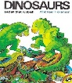

**MFL**

* Learn the colours in French and Spanish.
* Learn spring months and weather and Easter greetings in French and Spanish.

**Design and Technology**

**Select from and use a wide range of junk/recycled materials.**

**Select from and use a range of tools and equipment to perform practical tasks to upcycle a household object. (WASTE WISE KIDS COMPETITION)**

- Make a sea creature out of household waste. E.g. a jellyfish (linked to Michael Rosen’s poem)

- Design and create a fun and environmentally friendly Easter themed thing for the home.

**Art**

**Use drawing, collaging and printing to develop and share their ideas.**

* Illustrations- look at the work/style of author/illustrator Michael Foreman. Explore and use contrasting colours in same scene from a story setting to create different mood/effects. Collage using recycled papers.(Linked to narrative writing)
* Printing- use recycled materials for printing. Aluminium Foil printing (simple version of etching and engraving)

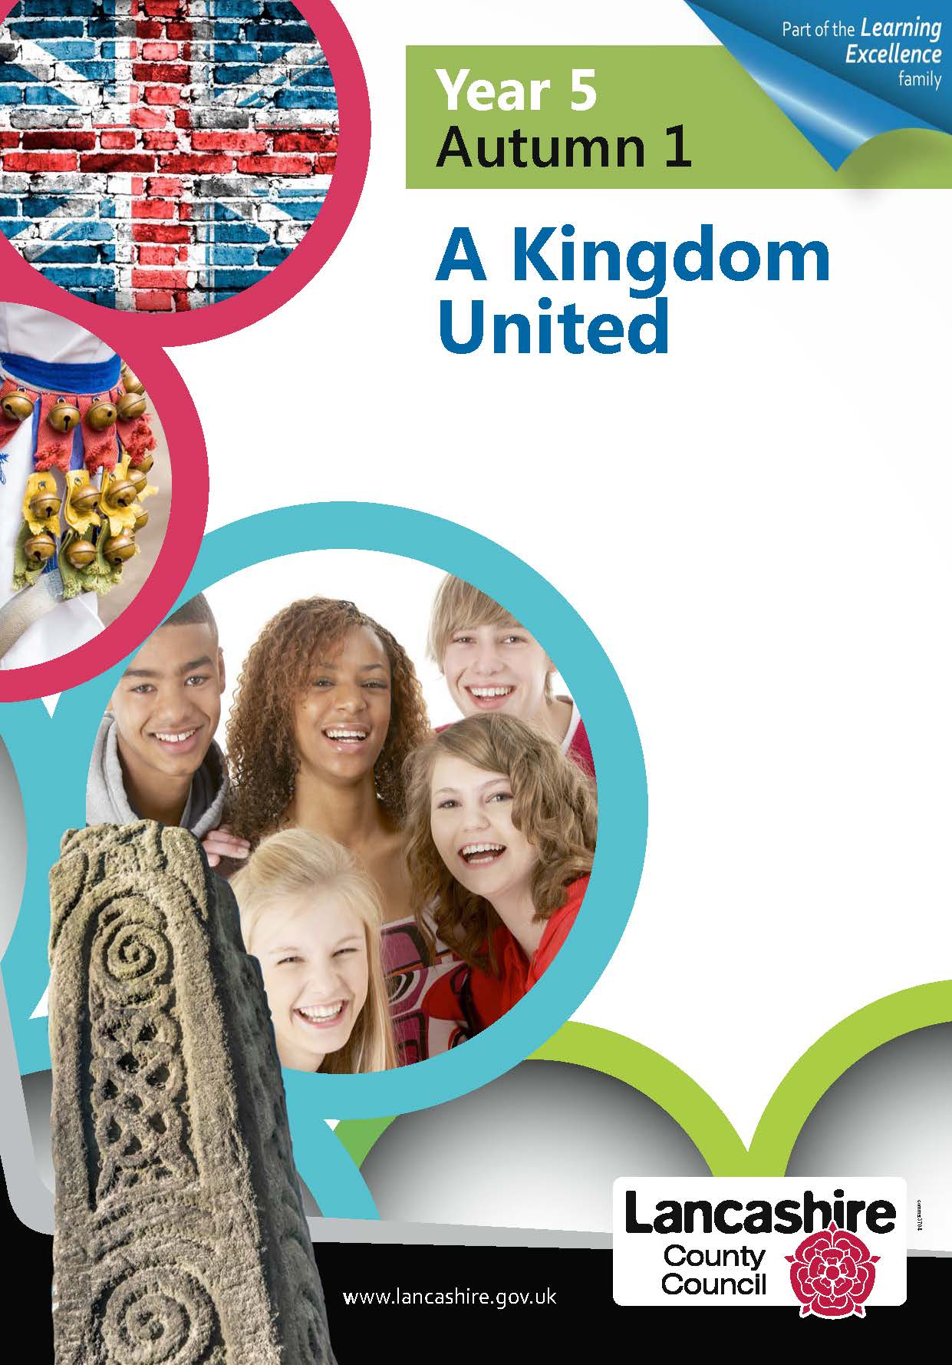

**Music**

**Developing creativity and appreciation and a love of music**

* Exploring and identifying untuned percussioninstruments.
* Using household objects and junk materials to create simple percussion instruments.
* Listen to/watch the musical group ‘Stomp’. Use as inspiration for own group percussion work using the body and ordinary objects to create a physical theatre performance.

**Geography**

Locational knowledge**:**

**Name and locate some counties and cities of the United Kingdom.**

**Human Geography:**

**Look at the impact of waste on large towns and cities. Consider local waste management projects/initiatives. What does Warwickshire do? What does Heathcote do? Could we do more? Use ‘Waste Wide Kids’ link.**

**Find/read news stories from around the world linked to pollution, the environment and locate places on world map.**

**Geography skills and fieldwork:**

**Use maps and atlases**

**Use fieldwork (around school community) to observe, measure, record and present human features e.g. recycling bins, rubbish collections, monitor waste generated by school/by families etc.**

**PSHE**

**Belonging to a Community- linked to British values and citizenship)**

* Working together in school, in our local community, in Warwickshire to look after the environment (rights and responsibilities) and promote the 3Rs and sustainability.

**It also links clearly with our SMSC development.**

**History**

**Learn about events beyond living memory that are significant nationally or globally.**

MARCH- WOMEN’S HISTORY MONTH (Focus on Women in Stem as link to Science Week)

Research and develop a chronology- working back from modern day.

1. Greta Thunberg (Sweden) 2003-
2. Katherine Johnson (America) 1918- 2020
3. Marie Curie (Poland) 1867- 1934
4. Florence Nightingale (England) 1820-1910
5. Mary Anning (England) 1799-1847)

Link Mary Anning to dinosaurs through her fossil discoveries. Make a timeline showing when dinosaurs and humans have been alive.