Maths
Recapping and revisiting work on place value.
Daily focus activities around multiplication tables. We will continue to monitor any gaps in learning, and revisit previous years objectives to ensure full coverage.

Number: Multiplication and division– recall and use multiplication and division facts for the 3, 4 and 8 tables; look at using written and mental methods to solve problems, including missing number problems.
Measurement: Mass – measure, compare, add and subtract mass (kg/g) volume/capacity (l/ml)
Measurement: time
Tell and write the time from an analogue clocking, including using Roman numerals from I to XII, and 12-hour and 24-hour clocks; estimate and read time with increasing accuracy to the nearest minute.

English
Reading - Key text: Charlie and the Chocolate Factory by Roald Dahl
We will also look at a range of poetry and short stories with a food theme. In addition, we will look at recipes and non-fiction text about food around the world.
We will begin the term looking at “Ssh, we have a plan” and focus on:
We will explore this high quality picture book which allows children to put themselves inside the story and empathise with characters and their issues and dilemmas.
• We will engage with illustrations throughout the picture book to explore and recognise the added layers of meaning these can give to our interpretation of a text.
• We will explore how to use drawing and collage as an approach to enhance thinking for writing and developing vocabulary.
Whilst schools are shut we will look at various texts, videos and pictures to enthuse the children and help them develop as writers and readers during this lockdown period. These activities will be created to enable children to learn at home and in school effectively and consistently.
Developing pleasure and motivation to read. Word reading and comprehension skills through class texts and reading sessions and written activities. (Weekly skills building)
Reading skill focus – retrieving and sequencing
Choosing own texts and sustained reading for pleasure.
Dictionary use to check meaning.
Magpie interesting examples of character descriptions in class and independent books.
Speaking and Listening: discussion and presentation during topic work, hot seating characters.
Writing Composition - Writing for different purposes, developing stamina, editing and checking work throughout.
Narrative: looking at plots and structure of stories, creating a setting
Nonfiction: Writing recipes, reading and recording information pages, create an advert
Poetry: A selection of food related poetry and rhymes.
Spelling: Weekly spellings linked to No-Nonsense spellings (Key spelling list sent home)
Grammar: Linked to the National Curriculum requirements for Year 3
Handwriting: Children join and enhance the fluency and neatness of their writing.
Emphasis on neat presentation and pride in all written work.
Computing –
Branching data bases.
Touch typing email, includes email safety.

Religious Education
(According to Warwickshire and Coventry agreed syllabus for RE 2017)
Key Question: Why is the bible important to Christians today?
- Talk about books that are special to them
- Looking at how Christians use the Bible at church and at home,
- Delving a little deeper into the Bible, finding out how it is organised
- Comparing some of the different genres and purposes of writing within.

Science
Animals. Including humans
- Identify that animals, including humans, need the right types and amount of nutrition and that they cannot make their own food; they get nutrition from what they eat.
- Carry out different experiments to alter food, observe and identify scientific changes at work including reversible and irreversible changes.
- Use their senses to explore a range of food.

Music
Three little birds & The dragon song
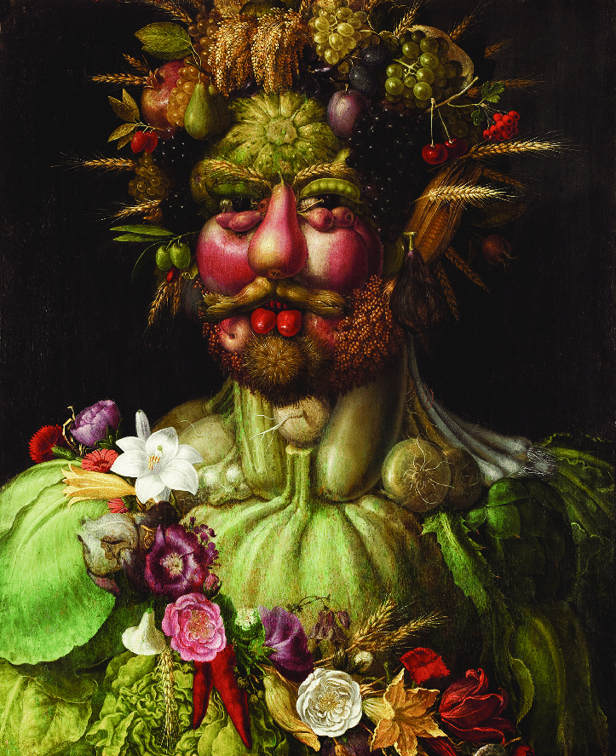
Scrumdiddlyumptious!
Curriculum Plan –
Spring 1 2021

Year 3

Mr Whatson
Mrs Forest

Spanish
- Food words
- Explore traditional Spanish dishes and food customs

British Values and SMSC
Developing an understanding of fundamental British values

Spiritual: Think about times in their own lives where they celebrated significant events/people and why and how they do this.

Morals: investigate moral and ethical issues linked to fair trading

Social: Look at how food plays a part in creating communities. Social skills linked to meal times, festivals and celebrations.

Cultural: Explore how food is celebrated and eaten in different cultures and customs related to food.

Democracy: An understanding that everyone plays an equal part within the food industry.

Individual liberty: understand how people in history in Britain and in different countries have fought to express their views, ideas and freedom.

Tolerance and respect:, understand that people can have different beliefs, views and ideas around food.
Physical Education
Developing movement skills, competence, agility and coordination individually and with others across a range of physical activity
Games & Exercise –
- Looking at how we keep our bodies and mind healthy through exercise.
- Look at healthy snacks and track how much water we drink throughout the day.

Weekly PE lesson taught by Onside Sport will focus on gymnastics.

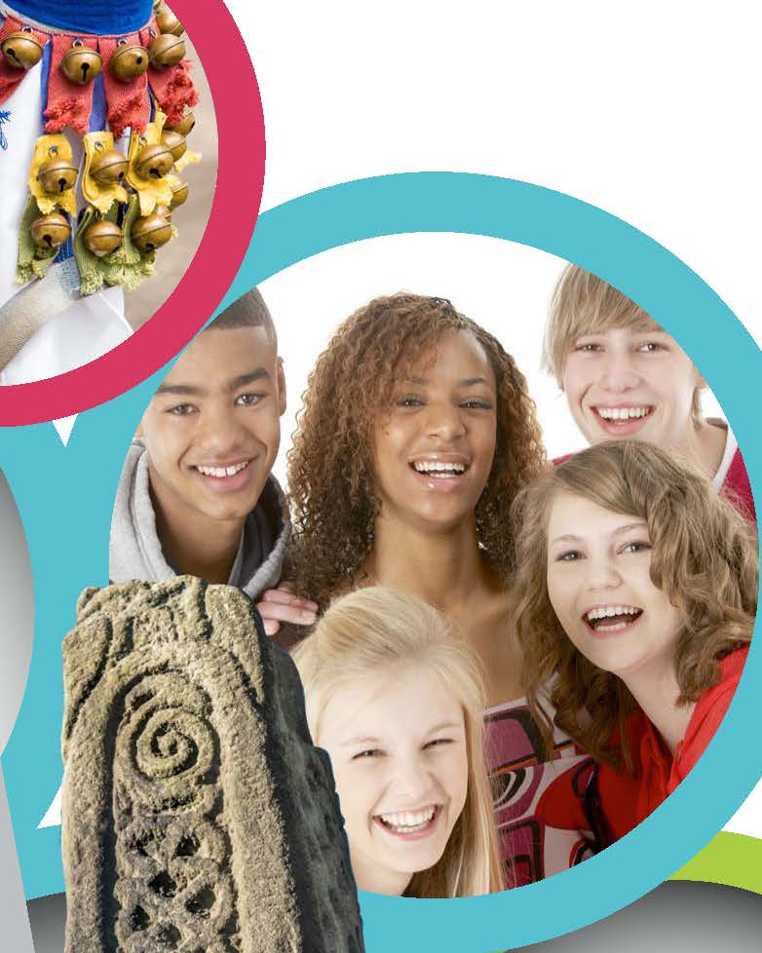
Super Activities: Hopefully when we’re back in school these can be arranged.
‘Fantastic Finish:

Art
Artist focus: Arcimboldo

To improve their mastery of art and design techniques, including drawing, painting with a range of materials.
Learn about great artists in history:
- Observational drawings of fruit and vegetables looking at colour, pattern and form.
- Sculpt a real or imaginary fruit using clay.

History
Looking at how chocolate sparked discovery, innovation and imagination throughout history
Look at the life of James Lind and the importance of healthy eating, especially when at sea.
Design and Technology
Use research and develop design criteria to inform the design of their product.
Generate, develop, model and communicate their ideas through discussion.
Select from and use a wide range of materials according to their functional properties and aesthetic qualities.
-Design and make packaging for a food product
-Sampling different foods from around the world

Geography
Locational knowledge:
-use maps, atlases, globes and digital/computer mapping to locate countries.
Mapping food miles around the world.
Fair trade fortnight;

PSHE
Fair trade fortnight – Equality of resources around the world and how farmers and workers are treated and not exploited.
Yoimoji (Cornerstones) activities

