**Maths**

**Number – multiplication and division** – Recall and use multiplication and division facts for the 2, 5 and 10 times tables, including recognising odd and even numbers.

Calculate mathematical statements for multiplication within the multiplication tables and write them using the multiplication (x) and equals (=) sign.

Solve problems involving multiplication using materials, arrays, repeated addition, mental methods and multiplications, including problems in contexts.

Show that the multiplication of two numbers can be done in any order (commutative).

**Statistics-** Making tally charts, drawing and interpreting pictograms and block diagrams.

**Fractions-** Parts and wholes, recognising and finding halves, quarters and thirds, unit and non-unit fractions, simple equivalence, finding three quarters, count in fractions, problem solving with fractions.

**Geometry-** Recognise, draw and sort 2D shapes, count sides and vertices on 2D shapes, make patterns with 2D shapes and lines of symmetry.

**English**

**Reading -** *Key text:* ***Ocean meets Sky by The Fan Brothers***

*A range of appropriate nonfiction texts and online research.*

**Developing pleasure and motivation to read.** Word reading and comprehension skills through class texts and reading sessions and written activities. (Weekly skills building)

Choosing own texts and sustained reading for pleasure.

**Speaking and Listening:** discussion and presentation during topic work

**Writing Composition - Writing for different purposes, developing stamina, editing and checking work throughout.**

***Narrative:*** Dialogue writing, diary/ log book, letter writing

***Nonfiction:*** Cross-curricular links – instruction writing, recipe writing, information leaflet.

***Spelling:*** Weekly spellings linked to No-Nonsense spellings-Suffixes

***Grammar:*** Linked to the National Curriculum requirements for Year 2 (Tenses, Sentence types- exclamations and statements)

***Punctuation:*** Apostrophes to mark where letters are missing and for singular possession in nouns.

***Handwriting:*** Children join and enhance the fluency and neatness of their writing.

Emphasis on neat presentation and pride in all written work.

**Computing –**

**Use technology purposefully to create, organise, store, manipulate and retrieve digital content.**

Children record videos and take photos of their research about China. Use multimedia software to edit their photos and videos.

**Religious Education**

**(According to Warwickshire and Coventry agreed syllabus for RE 2017)**

**1. Key Question: Who are the Jewish and what do they believe?**

**Key Question:** How and why do we celebrate special and sacred times?

* Look at the Chinese New Year and reflect on how and why people celebrate special and sacred times.
* Look at how we celebrate with our families and friends and the stories we share with our families.
* What times are special and why?
* How can people express the spiritual through the arts?
* Why are festivals important?

**Science**

**Broaden scientific understanding of the world through exploration, observation, research and testing in the topic area of** **Everyday Materials**

* Why do boats float?
* Investigate waterproof materials.

**Mandarin**

* Learn how to greet each other in Mandarin and ask and answer questions such as: ‘How are you?’ ‘What is your name?’ ‘How old are you?’
* Learn numbers 1 to 20

Ocean Meets Sky

Curriculum Plan –

Spring 1 2021

Year 2

Mrs Lawson,

Mrs. Abernethy, Mrs Ribbands and Miss Chadwick

**Music**

**Developing creativity and appreciation and a love of music**

* Exploring Traditional Chinese music

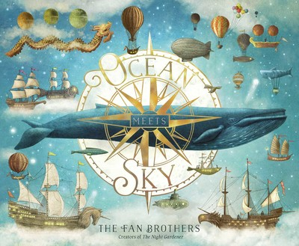

**Physical Education**

**Developing movement skills, competence, agility and coordination individually and with others across a range of physical activity**

**Health Related Fitness-**Ways of keeping fit, inside and outside during lockdown.

Recognising the importance of exercise for keeping fit and improving mental health.

**Dance –** Unit 1 –

Use a range of basic dance actions with understanding, work alone to create movement ideas, use different levels, directions and speeds.

**British Values and SMSC**

**Developing an understanding of fundamental British values**

**Spiritual**: Explore the relationship with their family, especially with elderly relatives.

Understand the importance of spirits in other cultures.

**Social and moral dilemmas**: Look at how festivals and celebrations bring communities together. Consider social and moral dilemmas that they come across in everyday life /

**Democracy:** Understand how kingdoms were ruled in the past.

**Cultural:** explore different countries beliefs and festivals.

**Individual liberty:**  understand how people in different countries would fight to express their views, ideas and freedom.

**Tolerance and respect:** understand that people can have different beliefs, views and ideas and that people can look different, dress different etc. and that we should show respect to everyone.

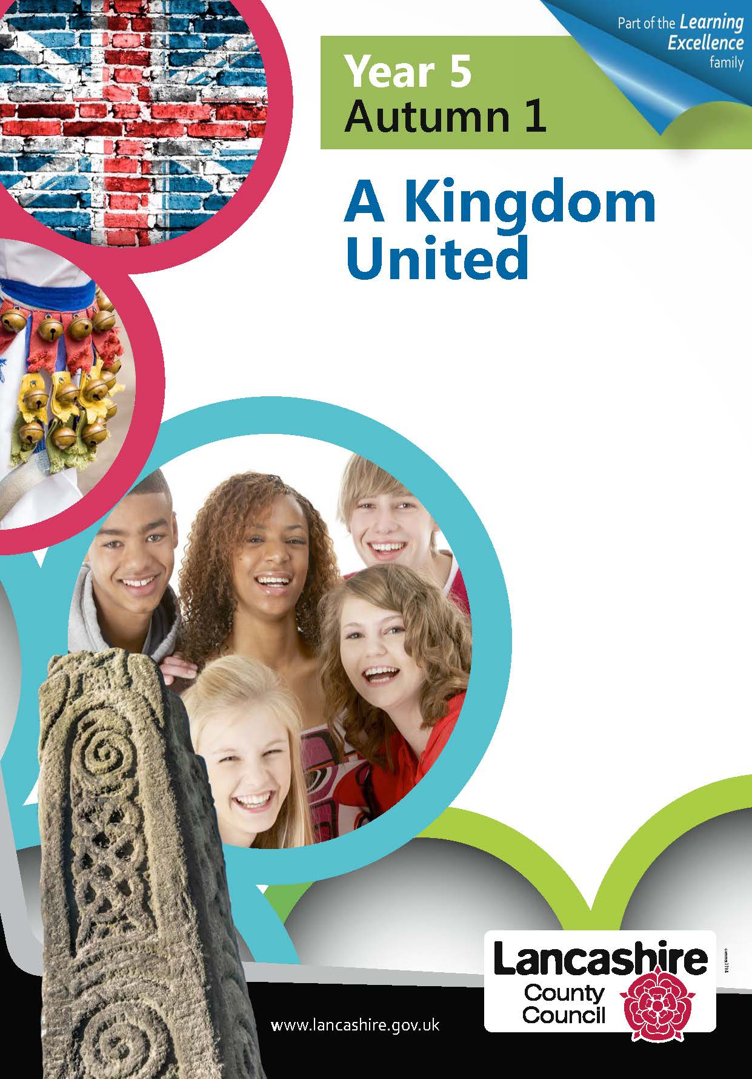

 



**Art**

**Use drawing, painting and sculpture to develop and share their ideas, experiences and imagination.**

* Calligraphy
* Illustrations (linked to the book)
* Artist study (sculpture)- The Terracotta Army

**Design and Technology**

**Select from and use a wide range of materials and components, including construction materials, textiles and ingredients, according to their characteristics.**

**Select from and use a range of tools and equipment to perform practical tasks.**

-Exploring, designing and make a boat.

- Cook dumplings

**PSHE**

**Good to be me –** recognising the difference between being proud and boastful, understanding my feelings, exploring mixed feelings, making judgements about whether to take a risk, agreeing and disagreeing

**It also links clearly with our SMSC development.**

**Geography**

**Name and locate the world’s 7 continents and 5 oceans.**

**Understand geographical similarities and differences through studying the human and physical geography of a small area of the United Kingdom, and of a small area in a contrasting non-European country.**

* Identify where the UK and China are on a map of the world – which continent they are in and their surrounding seas.

**History**

**Learn about events beyond living memory that are significant nationally or globally.**

* Research about the Chinese Lunar New Year
* Research how China have celebrated their New Year over the centuries, compare traditional to modern celebrations.