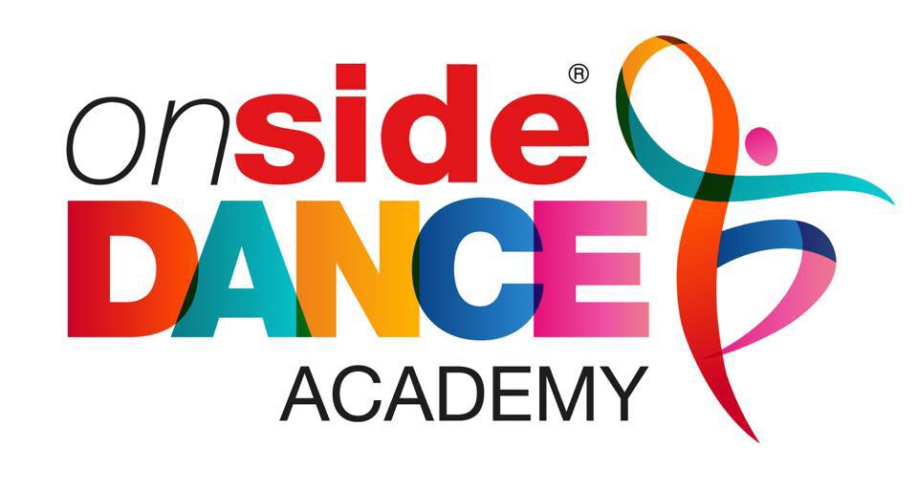
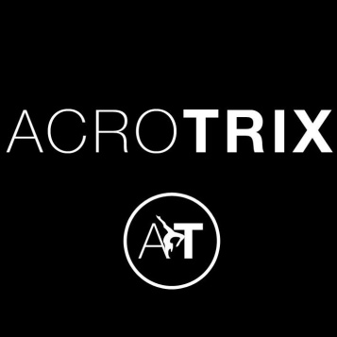

Wednesday and Thursday ACRO-GYMNASTICS
Wednesday 3:15-4:15pm - Reception – Year 1
Thursday 3:15-4:15pm - Year 2 – Year 5

Starting back Wednesday 16th and Thursday 17th September – 16th/17th December
13 sessions £58.50 (Contact Kerry to book and pre pay)

Do you love Acro-Gymnastics? If yes then you will love our brand new afterschool club. This term in Acro-Gymnastics club; you will be entering the circus and becoming acrobats learning new Tricks, Lifts and Balances with your class mates, learn new routines; work on cartwheels, forward rolls, bridges, forward walk overs and much more in this amazing after school club.

Email or Call Kerry to secure your place (details below)

Contact details:
Kerry Childs
07855533442
Kerry@onsidecoaching.co.uk

Onside dance academy

We are super excited to announce that the ‘Onside dance academy’ is BACK!

Starting Thursday 17th September with our new timetable.

4:30-5:15pm Mini pop fusion age 4 – 10 years

5:15-6:00pm Acrotrix Gymnastics age 4 years plus

6:00-6:45pm Intermediate pop fusion 11 years plus

Contact Kerry to book!

